Supporting Information

From Material Design to Mechanism study: Nanoscale Ni Exsolution on a Highly Active A-site Deficient Anode Material for Solid Oxide Fuel Cells

Yang Gao,*a* Dengjie Chen,*a,b* Mattia Saccoccio,*a* Ziheng Lu,*a* and Francesco Ciucci*a,c*\*

*a* Department of Mechanical and Aerospace Engineering, The Hong Kong University of Science and Technology, Hong Kong, SAR China. Tel: +852 2358 7187; E-mail: francesco.ciucci@ust.hk

*b* Department of Chemistry, Jinan University, Guangzhou, China

*c* Department of Chemical and Biomolecular Engineering, The Hong Kong University of Science and Technology, Hong Kong, SAR China

Table S1. Gibbs free energy (kJ mol-1) changes of the reduction reactions of A-site (a) and B-site (b) elements. The reaction is as MxOy + H2(g) = M + H2O(g). The data is generated by the HSC chemistry software.[1]

(a):

|  |  |  |  |  |  |  |  |
| --- | --- | --- | --- | --- | --- | --- | --- |
| **A-site** | **CaO** | **SrO** | **BaO** | **La2O3** | **CeO2** | **Pr2O3** | **Sm2O3** |
| 300 °C | 359.14 | 318.62 | 279.69 | 491.09 | 538.74 | 497.53 | 504.90 |
| 600 °C | 343.91 | 305.06 | 268.36 | 472.73 | 508.95 | 479.52 | 484.73 |
| 900 °C | 328.64 | 291.47 | 256.27 | 456.31 | 480.51 | 463.29 | 466.05 |

(b):

|  |  |  |  |  |  |  |  |
| --- | --- | --- | --- | --- | --- | --- | --- |
| **B-site** | **Sc2O3** | **TiO2** | **Cr2O3** | **Fe2O3** | **Co3O4** | **NiO** | **MoO2** |
| 300 °C | 545.49 | 408.10 | 54.07 | 10.54 | -57.67 | -29.16 | 50.60 |
| 600 °C | 525.43 | 385.82 | 45.35 | -4.09 | -74.96 | -40.00 | 28.84 |
| 900 °C | 507.25 | 365.89 | 40.91 | -16.54 | -90.78 | -49.54 | 10.38 |



Fig. S1. Gibbs free energy for the reduction of Sc, La, Sr, and Ni oxides to corresponding metals in H2. Generated by the HSC chemistry software.[2]



Fig. S2. (a): Relaxed structure of LSSN unitcell (La2Sr2Sc3Ni1O12) used for the bulk calculations. (b, c, d and e): Slab models used for calculating the Ni segregation energies projected onto the (100), (010), (001), and (121) planes, respectively.

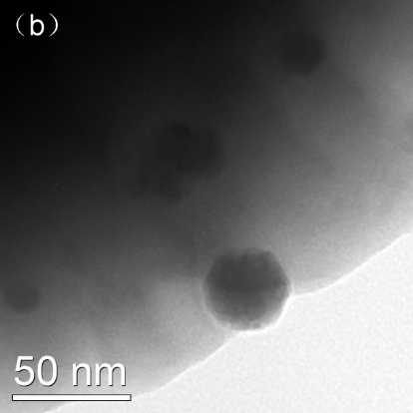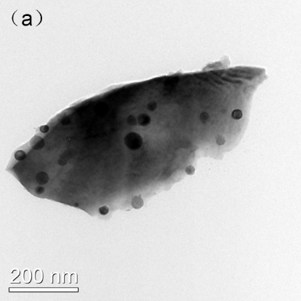

Fig. S3. TEM images of rLSSN with different magnification.



Fig. S4. XPS spectra of LSSN and rLSSN.

Fig. S5. Cross-sectional SEM image of LSSN/SDC symmetric cell with selected elemental mappings.

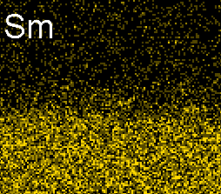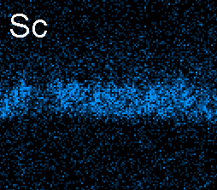

Table S2: Area specific resistance (ASR) of different anode materials.

|  |  |  |  |
| --- | --- | --- | --- |
| **Composition** | **Atmosphere** | **Temperature** | **ASR** |
| **Unit** | **%** | **°C** | **Ω cm2** |
| rLSSN this work | H2O/H2 (3/97) | 800 | 0.055 |
| LSTN this work | H2O/H2 (3/97) | 800 | 0.082 |
| LSTN[3] | H2O/H2 (3/97) | 800 | 0.075 |
| (Sr0.94)0.9(Ti0.9Nb0.1)0.9Ni0.1O3[4] | H2/N2 (20/80) | 800 | ~4 |
| Ni0.75Cu0.25/Nb1.33Ti0.67O4[5] | H2/N2 (20/80) | 800 | ~5 |
| (La0.2Sr0.8)0.9Ti0.9Fe0.1O3-δ[6] | H2/Ar (20/80) | 800 | ~3.5 |
| La0.75Sr0.25Cr0.5Mn0.5O3[7] | H2/H2O/Ar (5/3/92) | 850 | 0.6 |
| Sr2Fe1.5Mo0.5O6–δ[8] | H2O/H2 (3/97) | 750 | 0.46 |
| Pr0.8Sr1.2(Co,Fe)0.8Nb0.2O4+δ[9] | H2/N2 (5/95) | 800 | 0.44 |
| Ni/YSZ*[10] | H2O/H2 (3/97) | 700 | 0.27 |
| Ni/ScYSZ**[11] | H2O/H2 (3/97) | 750 | ~0.22 |

*: yttria-stabilized ZrO2

**: Sc2O3- yttria-stabilized ZrO2

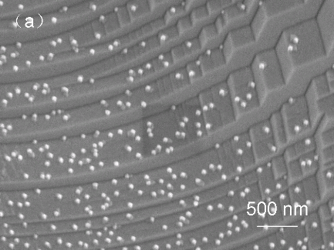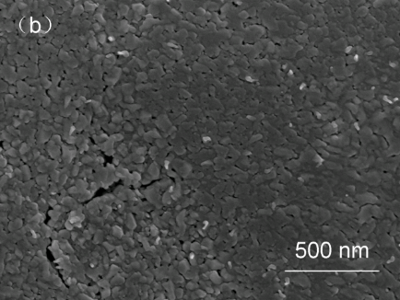

Fig. S6. (a): SEM images of LSTN reduced in pure H2 for 15 hours. (b): Dense flat surface of LSSN reduced in the same condition. The sample is prepared without adding carbon during calcination, and the surface has been polished.

Fig. S7. SEM images of rLSSN reduced in pure H2 at 900 oC for 5, 10, 15, 20, and 30 hours.

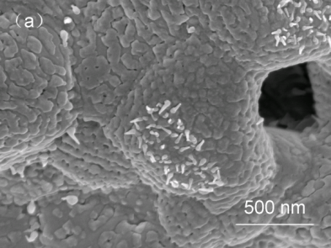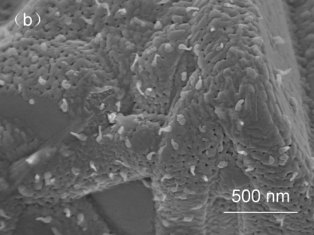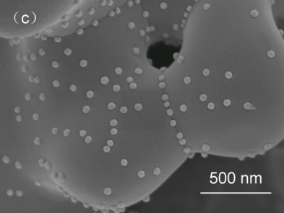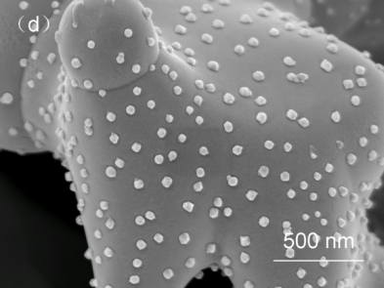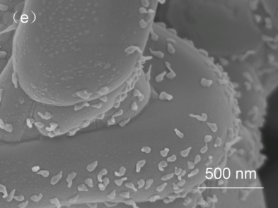

Fig. S8. SEM images of rLSSN reduced in 20% H2 with 80% of N2 at 900 oC for 5, 10, 15, 20, and 30 hours.

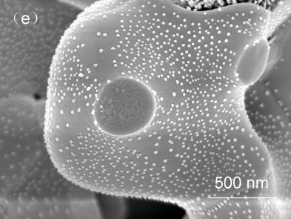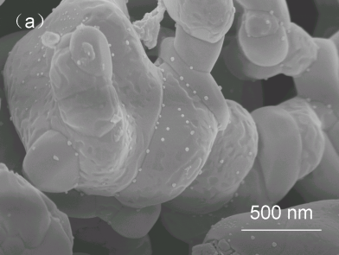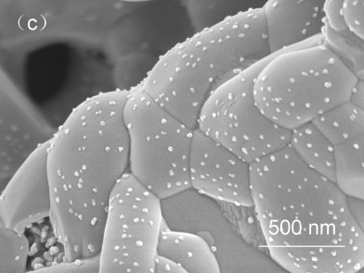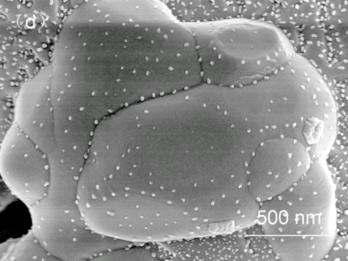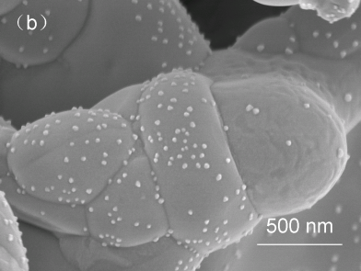



Fig. S9. The particle density (solid line) and estimated Ni metal ratio (dash line) in pure H2 (red) and 20% H2 (black).

Table S3. Summary of the three analytical models.

|  |  |  |
| --- | --- | --- |
| **Model** | $$r(t)$$ | **Limit** |
| Strain-limited | $$r_{s-lim}{\left(\ln\left(1+\frac{t}{τ_{s-lim}}\right)\right)}^{\frac{1}{3}}$$ | Activation energy caused  by the strain |
| Reactant-limited | $${r_{r-lim}\left(1-\exp\left(-\frac{t}{τ_{r-lim}}\right)\right)}^{\frac{1}{3}}$$ | Limited Ni concentration for the material supply |
| Diffusion-limited | $$r_{d-lim}{\left(\frac{t}{τ_{d-lim}}\right)}^{\frac{1}{6}}$$ | Ni diffusion coefficient and the geometry of the bulk |

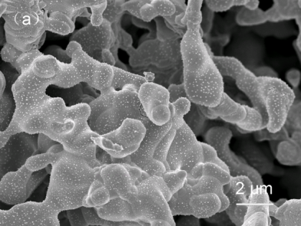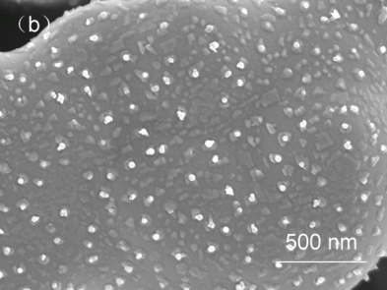

Fig. S10. (a) and (b): SEM images of LSSN reduced in H2 for 20 hours and then oxidized in O2 for another 20 hours.

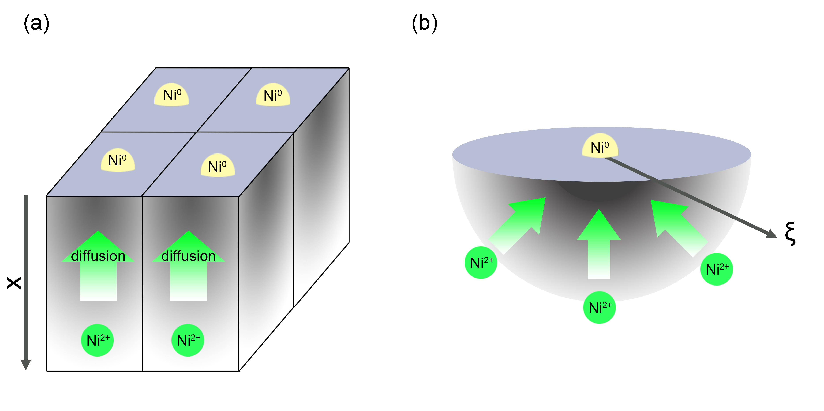

Fig. S11. Illustration of diffusion-limited exsolution model in the 1D (a) and 3D (b) cases.

## S1. Analytical modelling of particle growth

Three analytical growth models are proposed in the main text and are identified as limited by only one of the following factors: strain, overall reactant availability, or local reactant supply as determined by diffusion. In the following part of the SI, we will present the assumptions for each one of the models, and give detailed derivations.

## S1.1. General derivation of the reaction rate

The growth of the particle can be seen as the result of the following reaction:

|  |  |
| --- | --- |
| ${Ni}^{2+}(bulk)+O^{2-}(bulk) + H_{2}(gas)⇌ Ni(nanoparticles) + H_{2}O(gas)$ | (S1) |

The growth rate can be expressed as[12]

|  |  |
| --- | --- |
|  | (S2) |

where $S$ is the extension of the reaction site. $\dot{ω}$ is the overall reaction rate, which is equal to the difference between the forward and backward reaction rates ${\dot{ω}}_{f}$ and ${\dot{ω}}_{b}$,. We also note that for spherical particles $S∝r^{α}$ ( $r$ is the radius of the particle) and varies according to the site where reactions occur. For homogeneous reduction reactions happening in the bulk or on the bulk surface, $α=0$. If the reaction happens at the triple phase boundary (TPB) where gas, host material, and metal nanoparticle meet, the reaction rate depends on the length of the TPB and therefore $α=1$. If the reaction happens at the interface between the bulk and the particle, then the reaction rate depends on the surface area of the particle, and $α=2$.

For a general reaction equation[13]

|  |  |
| --- | --- |
|  | (S3) |

where $ν$ is the stoichiometric coefficient ( $'$ and $''$ stand for the reactants and products) and M is the arbitrary specification of the reacting chemical species ( $n$ and $m$ are the total number of reactants and products, respectively). Equation S(2) can be further expressed as

|  |  |
| --- | --- |
| $$\frac{dV}{dt}=S\left(k_{f}\prod_{i=1}^{n}{{\left(c_{i}^{'}\right)}^{ν_{i}^{'}}}-k_{b}\prod_{i=1}^{n}{{\left(c_{i}^{''}\right)}^{ν_{i}^{''}}}\right)$$ | (S4) |

where $k_{f}$ and $k_{b}$ are the forward and backward rate constants, which depend on temperature and reaction energetics, $c_{i}^{'}$ and $c_{i}^{''}$ are the concentration for $M_{i}^{'}$ and $M_{i}^{''}$. In the case of exsolution in analogy with nucleation theory,[14] we assume that the forward reaction dominates, giving

|  |  |
| --- | --- |
| $$\frac{dV}{dt}=Sk_{f}\prod_{i=1}^{n}{{c_{i}}^{ν_{i}}}$$ | (S5) |

where the $'$ is neglected for notational simplicity. The rate constant can be expressed as

|  |  |
| --- | --- |
| $$k_{f}=v_{0}exp\left(-\frac{E_{a}}{RT}\right)$$ | (S6) |

where $v_{0}$ is a constant pre-factor (we note that all constants will be lumped into the $v_{0}$ factor) and $E_{a}$ is the activation energy. By combining equation (S4) and (S6) we obtain

|  |  |
| --- | --- |
| $$\frac{dV}{dt}=v_{0}S exp\left(-\frac{E_{a}}{RT}\right)\prod{{c_{i}}^{ν_{i}}}$$ | (S7) |

if we assume that $E_{a}$ contains contributions arising from mechanical strain, that, for a spherical embedded particle, can be generally expressed as:

|  |  |
| --- | --- |
| $$E_{a}={E_{a}}^{0}+E_{s}\left(r\right)$$ | (S8) |

where ${E_{a}}^{0}$ is the activation energy without particle, and $E_{s}\left(r\right)$ is the strain energy as a function of particle radius. The growth rate then becomes:

|  |  |
| --- | --- |
| $$\frac{dV}{dt}=v_{0}r^{α}exp\left(-\frac{E_{s}\left(r\right)}{RT}\right)\prod{{c_{i}}^{ν_{i}}}$$ | (S9) |

Considering that $V∝r^{3}$, the integration of equation (S9) gives:

|  |  |
| --- | --- |
| $$\int_{r(0)}^{r(t)}{r^{2-α}{\left(\prod{{c_{i}}^{ν_{i}}}\right)}^{-1}exp\left(\frac{E_{s}\left(r\right)}{RT}\right)dr}=v_{0}t$$ | (S10) |

We note that for the particle growth, the integration of $r$ should start from the initial radius of the nucleated particle rather than 0.

## S1.1.1 Strain-limited exsolution

Under the assumption of unlimited supply of reactants ( $\prod{{c_{i}}^{ν_{i}}}$ is fixed), equation (S9) becomes

|  |  |
| --- | --- |
| $$\frac{dV}{dt}=v_{0}r^{α}exp\left(-\frac{E_{s}\left(r\right)}{RT}\right)$$ | (S11) |

We note that $v_{0}$ here includes the constant of $\prod{{c_{i}}^{ν_{i}}}$ and is dependent on the H2 partial pressure. $E_{s}\left(r\right)$ is the strain-induced activation energy caused by the deformation and interaction between the embedded particle and bulk material. The actual form of $E_{s}$ depends on the deformation and interaction between the bulk material, the particles[15] and is also influenced by the presence of a free surface.[16] For elastically isotropic particle and bulk material, previous studies have shown that the total strain energy is usually linear to the particle size as[1][17]

|  |  |
| --- | --- |
|  | (S12) |

is the strain energy per volume depending on the Young’s modulus and lattice mismatch. Equation (S11) can then be rewritten as:

|  |  |
| --- | --- |
| $$\frac{dV}{dt}=v_{0}r^{α}exp\left(-\frac{ϕ_{s}V}{RT}\right)$$ | (S13) |

In order to obtain an analytical expression, we assume that the reaction happens on surface of the bulk material near the particle and $α=0$. The solution can therefore be obtained as

|  |  |
| --- | --- |
| $$V=\frac{RT}{ϕ_{s}}\ln\left(1+\frac{v_{0}}{ϕ_{s}}t\right)$$ | (S14) |

Since the radius $r$ is linear proportional to $V^{1/3}$, we obtain

|  |  |
| --- | --- |
| $$r=r_{s-lim}{\left(\ln\left(1+\frac{t}{τ_{s-lim}}\right)\right)}^{\frac{1}{3}}$$ | (S15) |

where the strain-limited characteristic radius is $r_{s-lim}={\left(\frac{RT}{ϕ_{s}}\right)}^{\frac{1}{3}}$, and the strain limited characteristic timescale is given by $τ_{s-lim}=\frac{ϕ_{s}}{v_{0}}$. Equation (S15) corresponds to equation (6) in the main text.

## S1.1.2 Reactant-limited exsolution

When the activation energy is fixed and $exp\left(-\frac{E_{s}\left(r\right)}{RT}\right)$ is a constant equation (S9) becomes

|  |  |
| --- | --- |
| $$\frac{dV}{dt}=v_{0}\prod{{c_{i}}^{ν_{i}}}$$ | (S18) |

where reactants in (S1) include ${Ni}^{2+}$ and $O^{2-}$ in the host material and H2 gas. Assuming that all stoichiometric coefficients $ν$ are unitary, the particle volume growth rate can be expressed as:

|  |  |
| --- | --- |
| $$\frac{dV}{dt}=v_{0}c_{Ni^{2+}}c_{O^{2-}}c_{H_{2}}$$ | (S19) |

Sine that the maximum size is assumed to limited by the total amount of Ni, and Ni disperses homogenously in the bulk LSSN, we can enforce the constraint:

|  |  |
| --- | --- |
| $c_{Ni^{2+}}V_{b}+Vρ=c_{{Ni^{2+}}_{0}}V_{b}$ | (S20) |

where $c_{Ni^{2+}}$ and $c_{{Ni^{2+}}_{0}}$ are the current and initial concentrations of Ni ions respectively, $V_{b}$ is the (finite) volume being analyzed, and $ρ$ is the molar density of Ni metal. Moreover, other reactants are assumed to be constant due to equilibrium between the material and the gas. By combining equation (S19) and (S20), we obtain:

|  |  |
| --- | --- |
| $$\frac{dV}{dt}=v_{0}\left(c_{{Ni^{2+}}_{0}}-\frac{Vρ}{V_{b}}\right)$$ | (S21) |

where $v_{0}$ depends on the partial pressure of H2. Integrating (21) gives:

|  |  |
| --- | --- |
| $$V=\frac{V_{b}}{ρ}c_{{Ni^{2+}}_{0}}\left(1-\exp\left(\frac{ρv_{0}}{V_{b}}t\right)\right)$$ | (S22) |

And the radius $r$ is linearly proportional to $V^{1/3}$ as:

|  |  |
| --- | --- |
| $$r={r_{r-lim}\left(1-\exp\left(-\frac{t}{τ_{r-lim}}\right)\right)}^{\frac{1}{3}}$$ | (S23) |

where the reaction-limited radius $r_{r-lim}={\left(\frac{V_{b}}{ρ}c_{{Ni^{2+}}_{0}}\right)}^{\frac{1}{3}}$ and the reaction-limited characteristic timescale is $τ_{r-lim}=\frac{V_{b}}{ρv_{0}}$ Equation (S23) corresponds to equation (7) in the main text.

To support the hypothesis that the maximum size is determined by the limited Ni concentration in the bulk material, we have also estimated the particle density and the ratio of exsolved Ni metal of the whole Ni in the lattice. The results are plotted in Fig. S9 and discussed in the main text in Section 5.2.2.

## S1.2. Diffusion-limited exsolution

For the diffusion-limited exsolution, the growth will depend on the geometry of the slab and relative position of neighboring particles as illustrated in Figure S11. We will consider two limiting cases, one corresponding to multiple particles, where we will assume that the diffusion is nearly 1D and another case, where the particles are isolated, where the diffusion mechanism is spherically symmetric (3D). In the 1D case, the concentration of Ni2+ () is a function of the distance from the surface $x$ and time, *i.e.*, $c\left(x,t\right)$. The corresponding partial differential equation, initial and boundary conditions can be written as

|  |  |
| --- | --- |
| $$\frac{∂}{∂t}c\left(x,t\right)=D\frac{∂^{2}}{∂x^{2}}c\left(x,t\right)$$ | (S24a) |
| $$c\left(x,0\right)=c_{0}$$ | (S24b) |
| $$c\left(0,t\right)=0$$ | (S24c) |
| $$c\left(∞,t\right)=c_{0}$$ | (S24d) |

whose solution can be written simply as[18]

|  |  |
| --- | --- |
|  | (S25) |

The particle grows due to the supply of Ni diffusing to the $x=0$ plane. Therefore its volume can be computed from the amount of Ni present in the bulk

|  |  |
| --- | --- |
| $$V=\frac{1}{ρ}S\int_{0}^{∞}{\left(c_{0}-c\left(x,t\right)\right)dx}=\frac{2}{\sqrt{π}}\frac{{Sc}_{0}}{ρ}\sqrt{Dt}$$ | (S26) |

The radius $r$ can then be expressed as:

|  |  |
| --- | --- |
| $$r=r_{d-lmit}{\left(\frac{t}{τ_{d-lim}}\right)}^{\frac{1}{6}}$$ | (S27) |

where the diffusion-limited characteristic radius $r_{d-lim}={\left(\frac{2}{\sqrt{π}}\frac{{Sc}_{0}}{ρ}\right)}^{\frac{1}{3}}$ and the diffusion-limited characteristic timescale is $τ_{d-lim}={\left(\frac{1}{D}\right)}^{\frac{1}{6}}$. Equation (S27) corresponds to equation (8) in the main text.

For the 3D case, we assume instead that the particle grows by absorbing the Ni diffusing from the region $R≥a$. We take the concentration of Ni2+ as a function of the radial distance from the particle’s center $ξ$ and time, *i.e.*, $c\left(ξ,t\right)$. The corresponding diffusion equation, boundary, and initial conditions can be written as

|  |  |  |
| --- | --- | --- |
| $$\frac{∂}{∂t}c\left(ξ,t\right)=D\frac{1}{ξ^{2}}\frac{∂}{∂ξ}\left(ξ^{2}\frac{∂c}{∂ξ}\right)$$ | | (S28a) |
| $c\left(ξ,0\right)=c_{0}$ ($ξ>a$) | (S28b) | |
| $$c\left(a,t\right)=0$$ | (S28c) | |
| $$c\left(∞,t\right)=c_{0}$$ | (S28d) | |

To solve this problem, we define $u\left(ξ,t\right)=ξ\left(c\left(ξ,t\right)-c_{0}\right)$. This allows us to rewrite the previous set of equations, boundary and initial conditions as[19]

|  |  |  |
| --- | --- | --- |
|  | | (S29a) |
| $$u\left(ξ,0\right)=0$$ | (S29b) | |
| $$u\left(a,t\right)=-ac_{0}$$ | (S29c) | |
| $$u\left(∞,t\right)=0$$ | (S29d) | |

This leads to:

|  |  |
| --- | --- |
| $$u\left(ξ,t\right)=-ac_{0}\operatorname{erfc}\left(\frac{ξ-a}{2\sqrt{Dt}}\right)$$ | (S30a) |
| $$c\left(ξ,t\right)=c_{0}-\frac{ac_{0}}{ξ}\operatorname{erfc}\left(\frac{ξ-a}{2\sqrt{Dt}}\right)$$ | (S30b) |

The particle volume over time can be computed as

|  |  |
| --- | --- |
| $$V=\frac{1}{ρ}\int_{a}^{∞}{2πξ^{2}\left(c_{0}-c\left(R,t\right)\right)dξ}=\frac{2\sqrt{π}ac_{0}}{ρ}\left(\sqrt{π}Dt+2a\sqrt{Dt}\right)$$ | (S31) |

this result shows a faster growth rate ($V∝t$) compared with the planar diffusion case ($V∝\sqrt{t}$) in equation (S26). The radius $r$ can then be expressed as:

|  |  |
| --- | --- |
| $$r={\left(\frac{2\sqrt{π}ac_{0}}{ρ}\left(\sqrt{π}Dt+2a\sqrt{Dt}\right)\right)}^{\frac{1}{3}}$$ | (S32) |

While spherical diffusion is certainly important, the high particle density consistently observed in the SEM images suggests that 1D diffusion is likely a better approximation.

**References**

[1] A. Roine, in Outokumpu Research Oy Pori, Finland 2002.

[2] A. Roine, User's guide, version 2002, 5.

[3] B. H. Park, G. M. Choi, Electrochim. Acta 2015.

[4] L. Yang, K. Xie, S. Xu, T. Wu, Q. Zhou, T. Xie, Y. Wu, Dalton Trans. 2014, 43, 14147.

[5] H. Wei, K. Xie, J. Zhang, Y. Zhang, Y. Wang, Y. Qin, J. Cui, J. Yan, Y. Wu, Sci. Rep. 2014, 4, 5156.

[6] Q. Qin, G. Wu, S. Chen, W. Doherty, K. Xie, Y. Wu, Electrochim. Acta 2014, 127, 215.

[7] S. Tao, J. T. Irvine, Nat. Mater. 2003, 2, 320.

[8] Q. Liu, X. Dong, G. Xiao, F. Zhao, F. Chen, Adv. Mater. 2010, 22, 5478.

[9] C. Yang, Z. Yang, C. Jin, G. Xiao, F. Chen, M. Han, Adv. Mater. 2012, 24, 1439.

[10] J. R. Wilson, S. A. Barnett, Electrochem. Solid-State Lett. 2008, 11, B181.

[11] T. Ramos, M. Sogaard, M. B. Mogensen, J. Electrochem. Soc. 2014, 161, F434.

[12] F. Liu, F. Sommer, C. Bos, E. Mittemeijer, Int. Mater. Rev. 2007, 52, 193; J. W. Christian, The theory of transformations in metals and alloys, Newnes, 2002.

[13] I. Glassman, R. A. Yetter, N. G. Glumac, Combustion, Academic press, 2014.

[14] D. Kashchiev, Butterworth Heinemann: Boston.

[15] P. Sharma, S. Ganti, N. Bhate, Appl. Phys. Lett. 2003, 82, 535; P. Sharma, S. Ganti, J. Appl. Mech. 2004, 71, 663.

[16] R. Dingreville, J. Qu, M. Cherkaoui, J. Mech. Phys. Solids 2005, 53, 1827; D. Neagu, T.-S. Oh, D. N. Miller, H. Ménard, S. M. Bukhari, S. R. Gamble, R. J. Gorte, J. M. Vohs, J. T. Irvine, Nat. Commun. 2015, 6; T.-S. Oh, E. K. Rahani, D. Neagu, J. T. Irvine, V. B. Shenoy, R. J. Gorte, J. M. Vohs, J. Phys. Chem. Lett. 2015, 6, 5106.

[17] M. Sun, Y. Dong, G. Zhang, J. Qu, J. Li, J. Mater. Chem. A 2014, 2, 13635; F. Nabarro, "The strains produced by precipitation in alloys", presented at Proceedings of the Royal Society of London A: Mathematical, Physical and Engineering Sciences, 1940; H. Ulbricht, J. Schmelzer, R. Mahnke, F. Schweitzer, Thermodynamics of Finite Systems and the Kinetics of First-Order Phase Transitions. Series: Teubner-Texte zur Physik, ISBN: 978-3-322-96428-1. Vieweg+ Teubner Verlag (Wiesbaden), Edited by Heinz Ulbricht, Jürn Schmelzer, Reinhard Mahnke and Frank Schweitzer, vol. 17 1988, 17.

[18] J. Crank, The mathematics of diffusion, Oxford university press, 1979.

[19] H. S. Carslaw, J. C. Jaeger, Oxford: Clarendon Press, 1959, 2nd ed. 1959.

1. It is important to note, that while we have taken $E_{s}$ to depend linearly with respect to the volume, other functional relations are perhaps more realistic in specific cases, *e.g.*, .

   9. J. Lee, Y. Earmme, H. Aaronson and K. Russell, *Metall. Trans. A*, 1980, 11, 1837-1847.

   10. D. Kashchiev, Butterworth Heinemann: Boston.